**Craters**

Today in Science class, Mr. Smith taught us about craters.

Things I learned:

* A crater on the moon is something whose floor goes below the standard ground level.
* A crater is 10 times larger than the rock that made it.
* Craters blow up like a grenade because they get so hot so fast.
* The debris lines from crater impacts are called rays.
* When a drop of water hits a pond it forms ripples. The water surface springs the drop back upward.
* This also happens with craters sometimes.
* This makes a cone in the middle of the crater, which makes it called a complex crater.
* Craters without this cone are called simple craters.
* 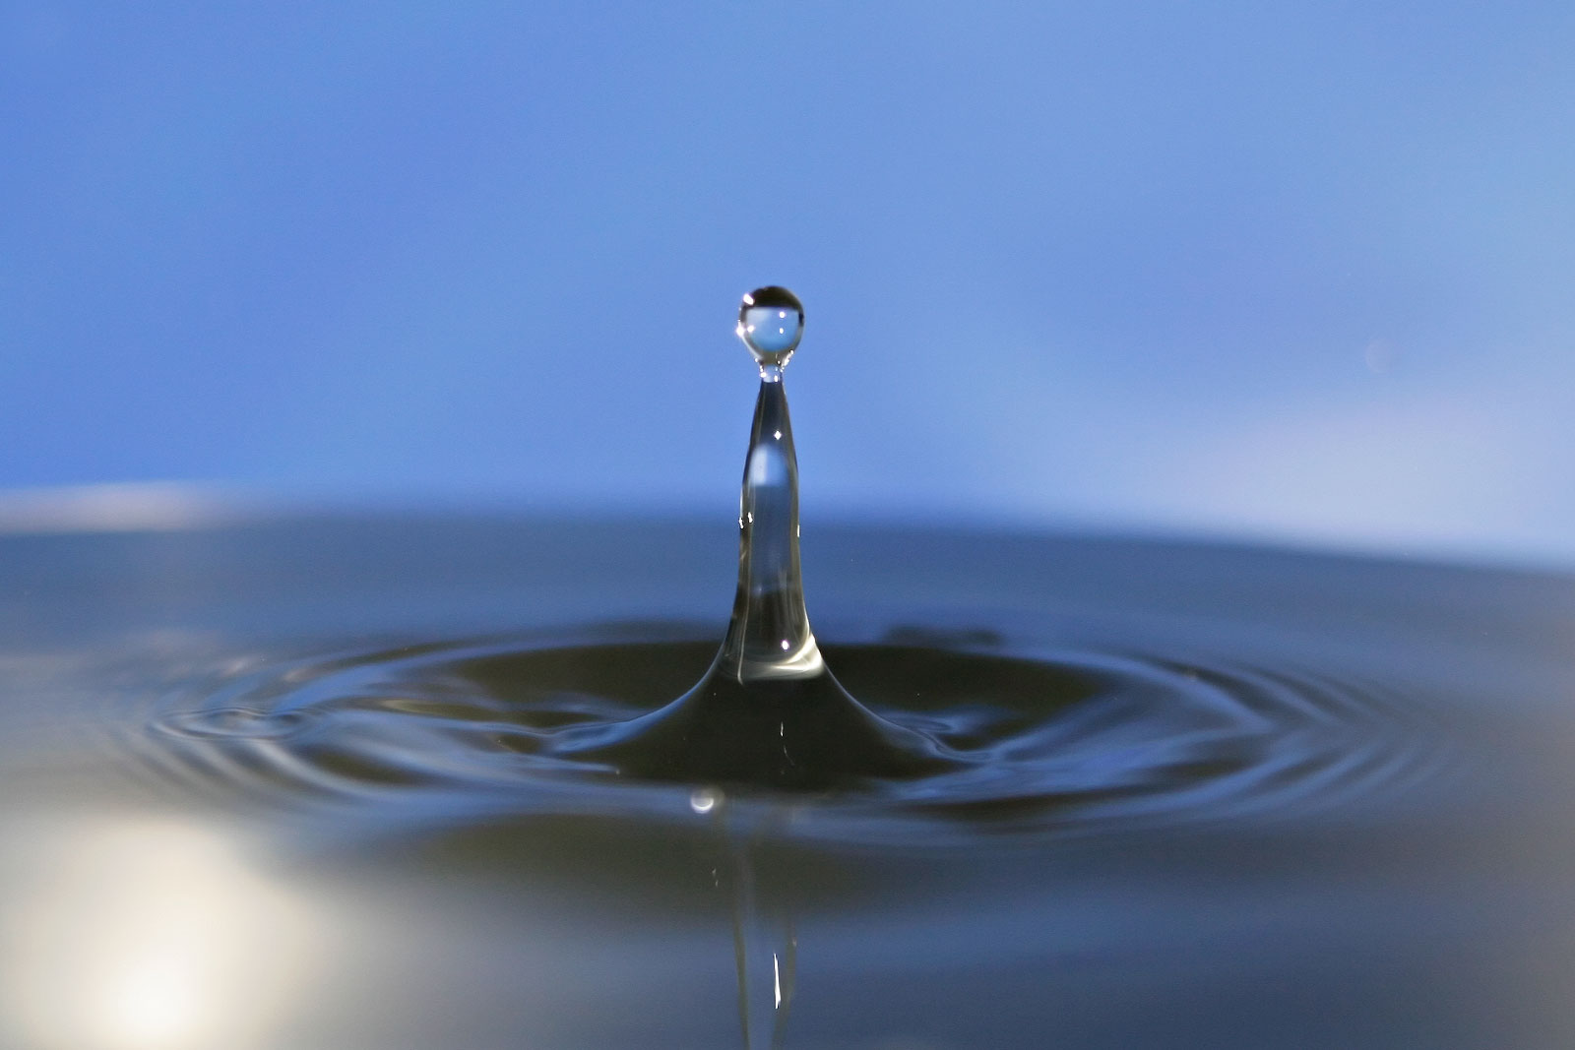There are a lot of craters on the moon.